Export Inventory
- Add ExportGenerator.dll in your Plugins\Reports folder, overwriting existing ones.
- Create a folder in your PC-POS folder called EXPORT (may exist since before)
  - In this folder create a new folder called eg "TREK"
- Add update.txt to the TREK folder
- In your output .txt file, specify which column or data should have in the export file. De fields with -1 are not included in the export.
This is what it should look like for so-called TREK export:
[CASH REGISTER]
ORGNO=5
[ITEM]
BARCODE=2
STOCK=3
SALESPRICE=4
Under the flag "[GENERAL]" there is a line called: SUPPLIER_CODE=[TREK]
It is this code, you must enter in the listing of the suppliers you wish to include in the current export. SO all the supplier that has that code, in my example [TREK], in listing will be included in the export. If other suppliers are to accompany the export, the same code must be added to these suppliers. If you leave this “blank”, the whole article register will be exported. (Notice! This can take some time)
- Macro to export only:
##EXPORT_KOD#exportgen?items? TREK? C:\Program Files (x86)\Present - PC POS\Export\TREK\stock_trek.txt? #
This macro can advantageously be added to the day close button, so you export in connection with day trades.
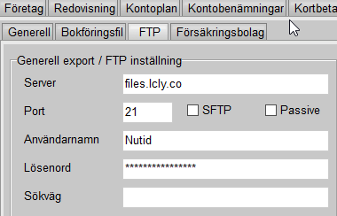
- Under File -> Company details -> Export settings -> FTP, add the FTP connection

Server: files.lcly.co
Username: Generate in Locally
Password: Generate in Locally
Port: 21

